Senior Seminar (COSC-4272)
Assessment of Lesson 4

Exercise 1. What are the approaches for meeting the audience’s needs? Give examples.

- There are three main methods of approaching the audience’s needs. As an example, let us look at a scenario to apply these methods:
  - Scenario: At a major financial company, we are trying to let our clients know about major transactions that happen in accounts that relate to them. We need it to be secure, safe, reliable, and easy to understand. The presentation we are giving them needs to be catered to the audience to help them understand what is going on.
  - Method 1: The Google Approach
    - In this method, you would do a general google search to see if possible solutions already exist. This is great to get a grasp on what is out there, but has potential downsides, such as just seeming like a report written in various formats and just not being personal.
    - In applying this to the scenario, this would look like giving what current methods are out there. A successful usage of this would be pointing out the pros and cons of each service and engaging the audience to what is suitable for them (demographic and personal desires).
  - Method 2: The Clinical Approach
    - This method is straightforward, just stating facts with no excess knowledge. The focus is clear and accurate information. The downside of this is the bland presentation that may put audiences to sleep.
    - Application in this scenario would just be stating what the company desires to do, how long it will take, what the expected cost of the project is, and other straightforward facts.
  - Method 3: The Audience-Geared Approach
    - This method is meant to actively engage the audience, taking into account who they are and retaining their attention.
    - This method includes facts and questions, encouraging the audience to engage in what they want from the application and giving them precise and satisfying answers for the account application.

Exercise 2. What are the key factors to getting and keeping your audience’s attention and keeping them interested? Give examples.

- Accurate and Relevant Title – The title itself should make the reader want to pick up and read what your are talking/writing about. This, however, needs to be accurate.
  - Ex: Converting a title from “CNN Models in Medicine” to “Using AI Models to Analyze and Detect Anomalies in Patient Data”
- Intriguing Information – Focused for documents, starting with intriguing information/data keeps the reader on their toes, making sure they aren’t just passively reading.
  - Ex: “About 50% of misdiagnosis occur due to incorrectly acquired or inputted data”
- Envision a Live Conversation – Writing like you are having a conversation allows the reader to better adjust and engage with the content, even encouraging the reader to have a conversation with the text.
  - Ex: “Though you may be thinking this is due to simple machine errors that can be easily corrected, much of the time, this comes from far worse scenarios…”
- Cover the Basics – You don’t want a reader/audience to feel like they have just been dropped into a passage. By covering the basics, you will provide the relevant background context to the upcoming material.
  - Ex: “CNN models are known for image analysis. In fact, out of all applications, utilization for medicine practically relies on these types of models.”
- Add humor or pictures – This lets the audience step back from just raw text. This encourages engagement.
  - Ex: 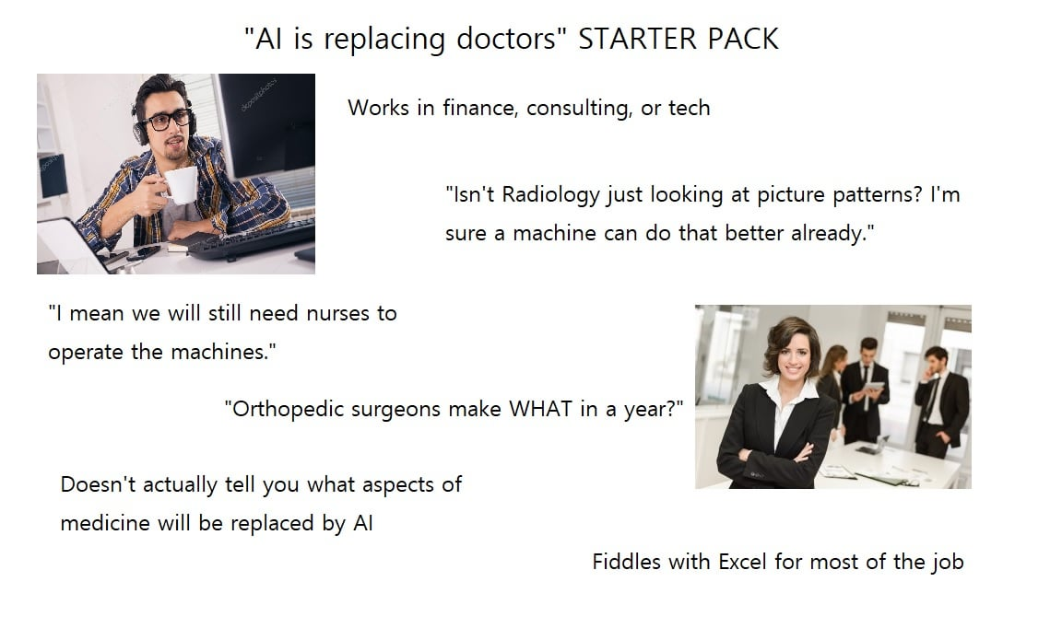
- Lighten Up – Information sticks more in an entertaining and relaxed setting.
  - Ex: “Great news about AI is that it doesn’t have feelings! It’s great because we really train it off some horrifying stuff …”
- Start Strong – Starting the paper/presentation strongly keeps the reader engaged from the beginning, leading to less of the audience being lost or confused.
- Keep Audience Comfy – For oral presentations, check if everything is set.
  - Ex: Comfortable temperature
- Speak Up – A small voice will produce a small reaction; a loud voice will give a large reaction.
  - Ex: Self explanatory

Exercise 3. Compare and contrast the barriers of effective written communications with the barriers of effective oral communications? Give example.

- The barriers of effective written communications are:
  - Clarity
  - Format
  - Reading Fatigue
  - Limited Time
  - Information Overload
- The barriers of effective oral communications are:
  - Bias
  - Language (accents or differences)
  - Noise/Environmental Factors
  - Short Attention Span
  - Distractions
  - Content
  - Style
- The similarities are mostly in the content. If there is much content, the audience or reader will get distracted, will not understand, may feel like there is too much information, and may have a limited time to understand the large quantity of information.
- The differences are in the context/presentation. Barries of written communication are more focused on the presentation of the paper and how it is suited to the audience. Barries of oral communication lie in how the presenter presents, through their communication skill’s (language and external factors) and how the audience sees them (bias).

Exercise 4. What are the responsibilities of the team leader in comparison with the rest of team members? Give examples.

- Team leaders have certain responsibilities that differentiate them from members. These include being the judge in disagreements, assigning tasks to the team members, being sensitive to the needs and skills of the members without being lax, keeping track of progress, and helping the intra-team communication skills. They must also be the communication point between superiors and other teams (inter-team communication).
- The members are those that are assigned tasks and must do their absolute best to please and fulfill the requirements set by superiors (including by the team leader). This includes cooperatively working with other members, using the leader’s judgment, and trusting the leader on what skills you may and may not have. If certain skills you have are not being utilized or if you want to develop and gain some skills, a discussion with the leader is advised.

Exercise 5. What are the main methods for searching information? Give examples.

- Information can be found in a variety of places. Here is the best ways to gather information:
  - Library – Going to a local library or online library is a great way to gather primary and secondary sources.
  - Publications and Organizations – Many organizations publish good articles and documents. Accessing these will save much time as the reputable organizations do not wish to publish mediocre or incorrect information.
  - Personal Contacts – This includes professors or researchers in the field. Getting their insight allows for a deeper insight into the topic and opens up the discussion of what to expect.
  - Internet – The internet hosts many websites and documents that are easily accessible. Using web search engines cuts the time needed to find information. Great sites include Google, Yahoo, and Microsoft Live Search.

